Solving Hyperbolic Systems with FlexPDE
Robert G. Nelson
2/17/97

We pose the problem of solving the equation

KH = 0,

where H is a known field and K is to be determined. For our studies, we will take H to be given by

H = (x²-y²),

From which

H = 2 (xi-yj),

and the equation becomes

2 [xK_{x} – yK_{y}] = 0.

A family of solutions to this problem take the form

K = (x y)^{p}.

Specifying a square domain, x=(-1,1), y=(-1,1), with values K = x y specified along the diagonals, we should see hyperbolic contour lines for K.

The following FlexPDE descriptor specifies this problem, and the accompanying plot shows the required contours.

Note that FlexPDE automatically implements upwind differencing to stabilize for hyperbolic equations. Without upwinding, the Vandenberg solver option is required to successfully solve this problem.

TITLE ' Characteristic Trajectories for X^2-Y^2 '

SELECT
errlim = 1.e-4

VARIABLES
psi {Characteristic Trajectories }

DEFINITIONS
h = x**2 - y**2
Kexact = x*y
ux = dx(h) uy = dy(h)

INITIAL VALUES
psi = 1

EQUATIONS
ux*dx(psi) + uy*dy(psi) = 0

BOUNDARIES
REGION 1
start (-1,-1) line to (1,-1) to (1,1) to (-1,1) to finish
feature
start (-1,-1) value(psi) = x*y line to (0,0) to (1,1)
feature
start (1,-1) value(psi) = x*y line to (0,0) to (-1,1)

PLOTS
contour(psi)
surface(psi)

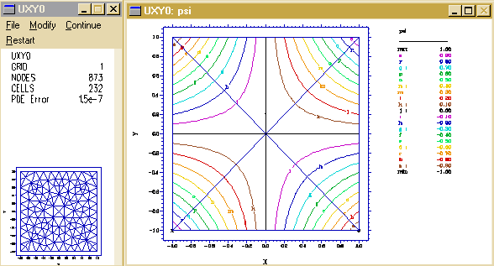
END

Adding Diffusion Terms

In many cases, the problem contains natural diffusive processes. In other cases, some artificial diffusion may be added for smoothing reasons. FlexPDE will integrate these terms by parts, imposing by implication a NATURAL boundary condition. If unspecified, the imposed condition is “zero normal flux”. If this boundary condition is not what is desired, the boundary effects of the diffusion terms may be cancelled by a “tautolological” boundary condition,

NATURAL(psi) = NORMAL(grad(psi)).

The following descriptor shows the addition of the diffusion term.

TITLE ' Characteristic Trajectories for x^2-Y^2 '

SELECT errlim = 1.e-4

VARIABLES psi {Characteristic Trajectories }

DEFINITIONS
h = (x^2-y^2) ux = dx(h) uy = dy(h)
eps = 0.001

INITIAL VALUES
psi = 1

EQUATIONS
ux*dx(psi) + uy*dy(psi) - eps*div(grad(psi)) = 0

BOUNDARIES
REGION 1
start (-1,-1)
natural(psi)=eps*dy(psi) line to (1,-1)
natural(psi)=-eps*dx(psi) line to (1,1)
natural(psi)=-eps*dy(psi) line to (-1,1)
natural(psi)=eps*dx(psi) line to finish
feature
start (-1,-1) value(psi) = x*y line to (0,0) to (1,1)
feature
start (1,-1) value(psi) = x*y line to (0,0) to (-1,1)

PLOTS
contour(psi)
surface(psi)

END

Solutions of Higher Order

The example solution shown is not typical, in that it can be exactly represented by the Finite Element basis. A more likely case is represented by the test solution

K = (xy) + 3(xy)²,

which cannot be exactly represented by the basis, and which generates local errors that perturb the solution process.

The “Vandenberg” Solver

PDEase and FlexPDE implement an optional Conjugate-Gradient solver due to Van den Berg. This technique uses the matrix product A^{t}A to symmetrize the system, and is sometimes effective in solving hyperbolic systems. The sequence of test problems AV1, AVD1, and AVD2 are three implementations of the Vandenberg algorithm. AV1 addresses the model problem without added diffusion. AVD1 and AVD2 add diffusion terms with coefficients of 0.001 and 0.01 respectively. These tests show that the Vandenberg method is only marginally effective in solving our sample problem:

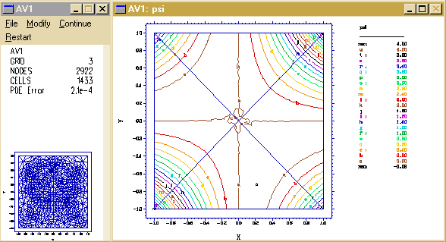
AVD1:

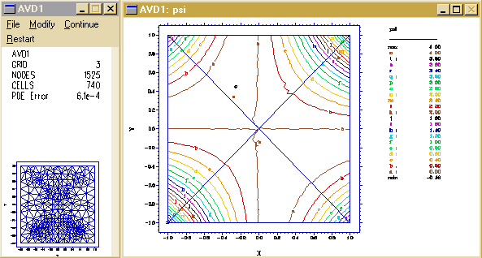
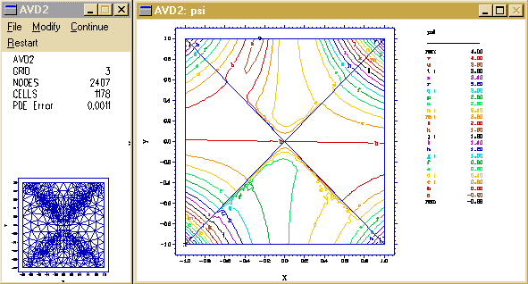AVD2:

Upwind Differencing

It has long been realized that standard Galerkin Finite Element techniques generate oscillatory solutions to hyperbolic systems. A common technique for rectifying this problem is the use of “upwinding”, which takes its name from an analogous Finite Difference technique, forming a one-sided difference approximation to the first derivative.

{Zienkiewicz and Taylor, “The Finite Element Method”, gives an extensive discussion of this topic in Chapter 12.}

An intuitive description of the technique can be given most conveniently for a one-dimensional system,

A ∂U/∂x - k ∂²U/∂x² + Q = 0.

This system can be stabilized by the addition to k of a “balancing diffusion” coefficient,

k_{b} = α A h/2,

where h is the cell size, and

α = coth|Pe| - 1/|Pe|  Pe/3 – Pe³/45 + ....

Here Pe is the Peclet number:

Pe = A h / 2 k.

In the case k=0, we get Pe → ∞, and α → 1, so

k_{b} → A h / 2 (Notice that k_{b} retains the sign of A).

Performing a little arithmetic with a Finite Difference approximation will show that k_{b} does, in fact, convert a centered difference approximation for ∂U/∂x to a one-sided difference on the upwind side.

In multidimensional systems, an analogous form is derived to apply a directional, or streamline, diffusion term to shift the differencing to the upwind side.

{In fact, the implementation in the Finite Element method is rather different than this, but the balancing diffusion concept is useful for comprehension. }

Upwind Solutions

The test problem AU1 attempts an upwind solution of our model problem. The solution is stable in the region downstream from the imposed values, but unstable upstream. That is, information cannot be propagated stably upstream.

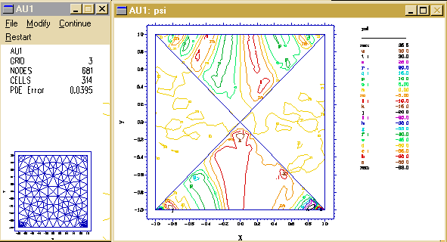

Augmented Upwinding

FlexPDE automatically implements upwinding, but it also allows the user to select an arbitrary scaling multiplier on the standard form.

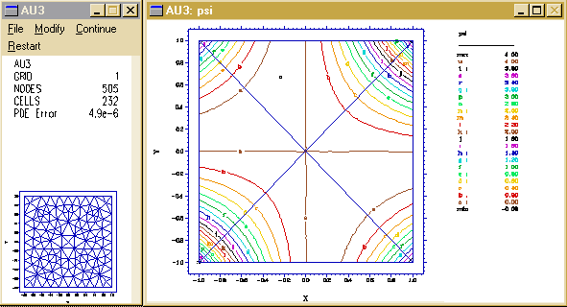Since diffusion can be interpreted as low-pass frequency filtering, and since upwinding is a directional diffusion, we would expect that large coefficients of upwind “balancing diffusion” could act as a noise-damping filter along streamlines. The test problem AU3, with an augmenting factor of 10, does in fact demonstrate that this is an effective solution of the upstream instability:

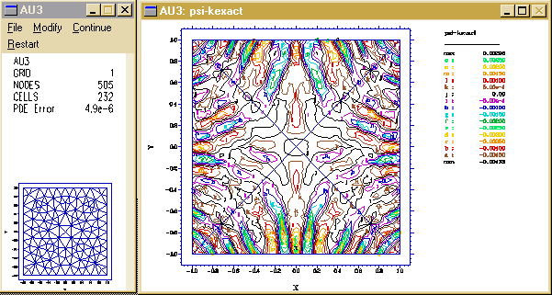
The deviation from the analytic solution is ±0.004:
Non-Analytic Solutions

So far we have been solving systems in which our programmed boundary values correspond to a known analytic solution of the PDE. It is typical of PDEase and FlexPDE that if the boundary conditions for a hyperbolic system are inconsistent or overdetermined the solver will fail. Here we investigate the robustness of the system in the presence of such inconsistencies. We use the same H field, but impose values of K = y along the diagonals. The three problems BV1, BV2 and BV3 use the Vandenberg solver with diffusion coefficients of 0, 0.001, and 0.01, respectively. The three problems, BU1, BU2 and BU3 use upwind scaling of 1, 10 and 100 respectively. BU1 did not converge.

BV1:
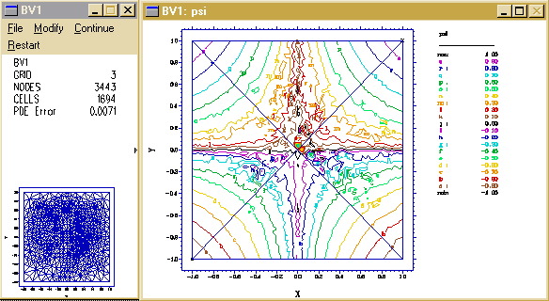
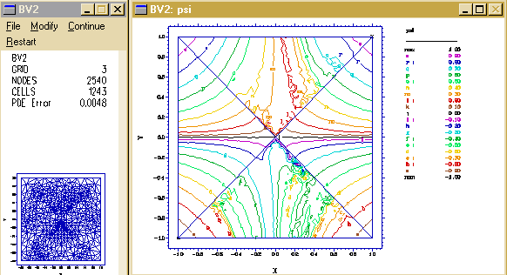
BV2:

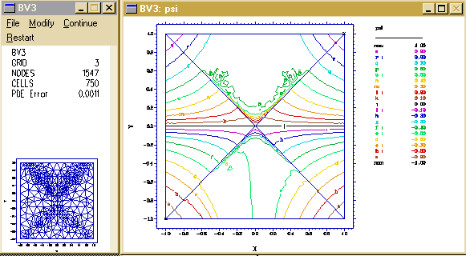
BV3:

BU2:
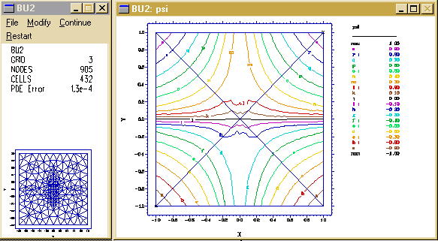
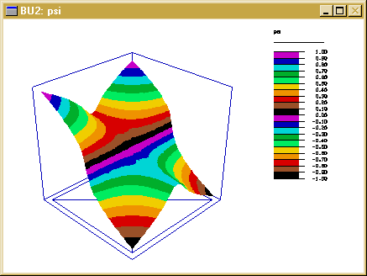
BU2 Surface:

BU3:
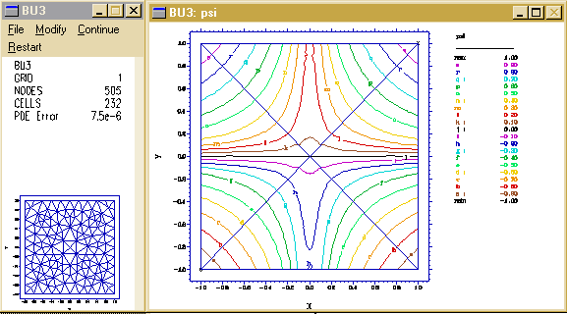
Undersampling

All of the problems so far considered have had complete definition by boundary conditions. That is, every stream line in the domain has somewhere intersected a defining boundary. We wish now to examine the consequence of only partial definition.

In the “C” series of problems, we have removed pieces of the defining features, leaving gaps at the corners and at the center. CU1 and CU2 are upwind methods, both with an upwind factor of 100. CU1 has no additional diffusion; it achieves a reasonable solution, but is beginning to diverge at the undefined tips. CU2 has an added isotropic diffusion of 0.01, like the previous Vandenberg runs; the impending divergence is better controlled in this case. CV1 and CV2 are Vandenberg solutions, without diffusion and with coefficient 0.01 respectively. CV2 has held together fairly well, but at higher cost than the upwind methods.

In the “D” series, we remove still more pieces of the defining features, in this case adding midrange gaps. We have left only a few short stubs of defined values. Problem DU2 uses an upwind factor of 100 with an additional isotropic diffusion coefficient of 0.01. It shows that a judicious combination of augmented upwind diffusion and isotropic diffusion can achieve a reasonable solution in spite of severe undersampling.

Problem EU2 removes the upper left defining feature, and shows that the absence of data in any flow cell can damage the entire solution.

CU1:
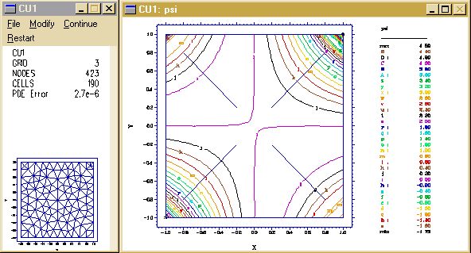
CU2:
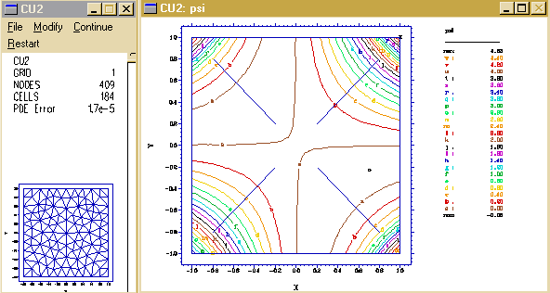
CV1:
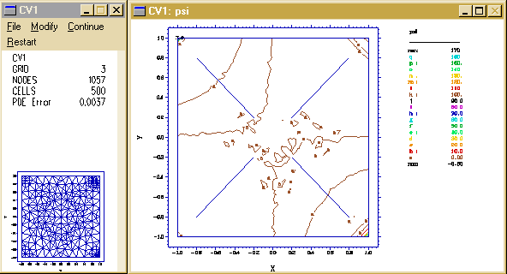
CV2:

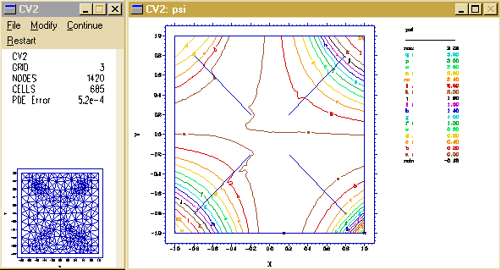
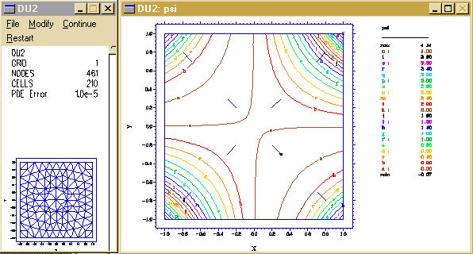
DU2:

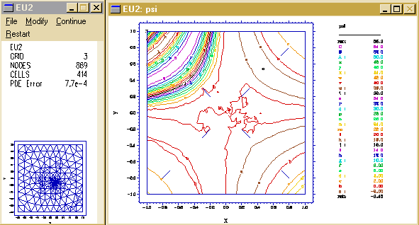
EU2:

Summary of Problems

Name Upwind Diffusion Nodes PDE Error K

AV1 0 0 2922 0.00021 0.04
AVD1 0 0.001 1525 0.0006 0.09
AVD2 0 0.01 2407 0.0011 0.64

AU1 1 0 681 0.04 70
AU3 10 0 505 0.0000049 0.003

BV1 0 0 3443 0.007
BV2 0 0.001 2540 0.0048
BV3 0 0.01 1547 0.0011

BU1 1 0 761 0.04
BU2 10 0 905 0.00013
BU3 100 0 505 0.0000075

CU1 100 0 423 0.0000027 6.0
CU2 100 0.01 409 0.000017 0.7

CV1 0 0 1057 0.0037 200.0
CV2 0 0.01 1420 0.00052 1.5

DU1 100 0
DU2 100 0.01 461 0.00001 0.18

EU2 100 0.01 869 0.00077 53.0

APPENDIX
Descriptor files for referenced problems

{ AV1: }

TITLE ' Characteristic Trajectories for X^2-y^2 '

SELECT
upfactor=0
vandenberg
iterate=1000
overshoot=0.0001

VARIABLES
psi {Characteristic Trajectories }

DEFINITIONS
h = x**2 - y**2
Kexact = (x*y) + 3*(x*y)^2
hx = dx(h) hy = dy(h)
eps = 0.001

INITIAL VALUES
psi = 1

EQUATIONS
hx*dx(psi) + hy*dy(psi) - eps*div(grad(psi)) = 0

BOUNDARIES

REGION 1
start (-1,-1)
natural(psi) = -eps*normal(grad(psi))
line to (1,-1) to (1,1) to (-1,1) to finish
feature
start (-1,-1) value(psi) = Kexact line to (0,0) to (1,1)
feature
start (1,-1) value(psi) = Kexact line to (0,0) to (-1,1)

MONITORS
grid(x,y)
contour(psi)
contour(kexact)

PLOTS
grid(x,y)
contour(psi)
surface(psi)
contour(psi-kexact)
surface(psi-kexact)

END

{ AVD1: }

TITLE ' Characteristic Trajectories for X^2-y^2 '

SELECT
upfactor=0
vandenberg
iterate=1000
overshoot=0.0001

VARIABLES
psi {Characteristic Trajectories }

DEFINITIONS
h = x**2 - y**2
Kexact = (x*y) + 3*(x*y)^2
hx = dx(h) hy = dy(h)
eps = 0.001

INITIAL VALUES
psi = 1

EQUATIONS
hx*dx(psi) + hy*dy(psi) - eps*div(grad(psi)) = 0

BOUNDARIES

REGION 1
start (-1,-1)
natural(psi) = -eps*normal(grad(psi))
line to (1,-1) to (1,1) to (-1,1) to finish
feature
start (-1,-1) value(psi) = Kexact line to (0,0) to (1,1)
feature
start (1,-1) value(psi) = Kexact line to (0,0) to (-1,1)

MONITORS
grid(x,y)
contour(psi)
contour(kexact)

PLOTS
grid(x,y)
contour(psi)
surface(psi)
contour(psi-kexact)
surface(psi-kexact)

END

{ AVD2: }

TITLE ' Characteristic Trajectories for X^2-y^2 '

SELECT
upfactor=0
vandenberg
iterate=1000
overshoot=0.0001

VARIABLES
psi {Characteristic Trajectories }

DEFINITIONS
h = x**2 - y**2
Kexact = (x*y) + 3*(x*y)^2
hx = dx(h) hy = dy(h)
eps = 0.01

INITIAL VALUES
psi = 1

EQUATIONS
hx*dx(psi) + hy*dy(psi) - eps*div(grad(psi)) = 0

BOUNDARIES

REGION 1
start (-1,-1)
natural(psi) = -eps*normal(grad(psi))
line to (1,-1) to (1,1) to (-1,1) to finish
feature
start (-1,-1) value(psi) = Kexact line to (0,0) to (1,1)
feature
start (1,-1) value(psi) = Kexact line to (0,0) to (-1,1)

MONITORS
grid(x,y)
contour(psi)
contour(kexact)

PLOTS
grid(x,y)
contour(psi)
surface(psi)
contour(psi-kexact)
surface(psi-kexact)

END

{ AU1: }

TITLE ' Characteristic Trajectories for X^2-y^2 '

VARIABLES
psi {Characteristic Trajectories }

DEFINITIONS
h = x**2 - y**2
Kexact = (x*y) + 3*(x*y)^2
hx = dx(h) hy = dy(h)
eps = 0

INITIAL VALUES
psi = 1

EQUATIONS
hx*dx(psi) + hy*dy(psi) - eps*div(grad(psi)) = 0

BOUNDARIES

REGION 1
start (-1,-1)
line to (1,-1) to (1,1) to (-1,1) to finish
feature
start (-1,-1) value(psi) = Kexact line to (0,0) to (1,1)
feature
start (1,-1) value(psi) = Kexact line to (0,0) to (-1,1)

MONITORS
grid(x,y)
contour(psi)
contour(kexact)

PLOTS
grid(x,y)
contour(psi)
surface(psi)
contour(psi-kexact)
surface(psi-kexact)

END

{ AU3: }

TITLE ' Characteristic Trajectories for X^2-y^2 '

SELECT
upfactor=10

VARIABLES
psi {Characteristic Trajectories }

DEFINITIONS
h = x**2 - y**2
Kexact = (x*y) + 3*(x*y)^2
hx = dx(h) hy = dy(h)
eps = 0

INITIAL VALUES
psi = 1

EQUATIONS
hx*dx(psi) + hy*dy(psi) - eps*div(grad(psi)) = 0

BOUNDARIES

REGION 1
start (-1,-1)
line to (1,-1) to (1,1) to (-1,1) to finish
feature
start (-1,-1) value(psi) = Kexact line to (0,0) to (1,1)
feature
start (1,-1) value(psi) = Kexact line to (0,0) to (-1,1)

MONITORS
grid(x,y)
contour(psi)
contour(kexact)

PLOTS
grid(x,y)
contour(psi)
surface(psi)
contour(psi-kexact)
surface(psi-kexact)
vector(hx,hy) as "Velocity"

END

{ BV1: }

TITLE ' Characteristic Trajectories for X^2-y^2 '

SELECT
upfactor=0
vandenberg
iterate=1000
overshoot=0.0001

VARIABLES
psi {Characteristic Trajectories }

DEFINITIONS
h = x**2 - y**2
hx = dx(h) hy = dy(h)
eps = 0

INITIAL VALUES
psi = 1

EQUATIONS
hx*dx(psi) + hy*dy(psi) - eps*div(grad(psi)) = 0

BOUNDARIES

REGION 1
start (-1,-1)
natural(psi) = -eps*normal(grad(psi))
line to (1,-1) to (1,1) to (-1,1) to finish
feature
start (-1,-1) value(psi) = y line to (0,0) to (1,1)
feature
start (1,-1) value(psi) = y line to (0,0) to (-1,1)

MONITORS
grid(x,y)
contour(psi)

PLOTS
grid(x,y)
contour(psi)
surface(psi)

END

{ BV2: }

TITLE ' Characteristic Trajectories for X^2-y^2 '

SELECT
upfactor=0
vandenberg
iterate=1000
overshoot=0.0001

VARIABLES
psi {Characteristic Trajectories }

DEFINITIONS
h = x**2 - y**2
hx = dx(h) hy = dy(h)
eps = 0.001

INITIAL VALUES
psi = 1

EQUATIONS
hx*dx(psi) + hy*dy(psi) - eps*div(grad(psi)) = 0

BOUNDARIES

REGION 1
start (-1,-1)
natural(psi) = -eps*normal(grad(psi))
line to (1,-1) to (1,1) to (-1,1) to finish
feature
start (-1,-1) value(psi) = y line to (0,0) to (1,1)
feature
start (1,-1) value(psi) = y line to (0,0) to (-1,1)

MONITORS
grid(x,y)
contour(psi)

PLOTS
grid(x,y)
contour(psi)
surface(psi)

END

{ BV3: }

TITLE ' Characteristic Trajectories for X^2-y^2 '

SELECT
upfactor=0
vandenberg
iterate=1000
overshoot=0.0001

VARIABLES
psi {Characteristic Trajectories }

DEFINITIONS
h = x**2 - y**2
hx = dx(h) hy = dy(h)
eps = 0.01

INITIAL VALUES
psi = 1

EQUATIONS
hx*dx(psi) + hy*dy(psi) - eps*div(grad(psi)) = 0

BOUNDARIES

REGION 1
start (-1,-1)
natural(psi) = -eps*normal(grad(psi))
line to (1,-1) to (1,1) to (-1,1) to finish
feature
start (-1,-1) value(psi) = y line to (0,0) to (1,1)
feature
start (1,-1) value(psi) = y line to (0,0) to (-1,1)

MONITORS
grid(x,y)
contour(psi)

PLOTS
grid(x,y)
contour(psi)
surface(psi)

END

{ BU2: }

TITLE ' Characteristic Trajectories for X^2-y^2 '

SELECT
upfactor=10

VARIABLES
psi {Characteristic Trajectories }

DEFINITIONS
h = x**2 - y**2
hx = dx(h) hy = dy(h)
eps = 0

INITIAL VALUES
psi = 1

EQUATIONS
hx*dx(psi) + hy*dy(psi) - eps*div(grad(psi)) = 0

BOUNDARIES

REGION 1
start (-1,-1)
line to (1,-1) to (1,1) to (-1,1) to finish
feature
start (-1,-1) value(psi) = y line to (0,0) to (1,1)
feature
start (1,-1) value(psi) = y line to (0,0) to (-1,1)

MONITORS
grid(x,y)
contour(psi)

PLOTS
grid(x,y)
contour(psi)
surface(psi)

END

{ BU3: }

TITLE ' Characteristic Trajectories for X^2-y^2 '

SELECT
upfactor=100

VARIABLES
psi {Characteristic Trajectories }

DEFINITIONS
h = x**2 - y**2
hx = dx(h) hy = dy(h)
eps = 0

INITIAL VALUES
psi = 1

EQUATIONS
hx*dx(psi) + hy*dy(psi) - eps*div(grad(psi)) = 0

BOUNDARIES

REGION 1
start (-1,-1)
line to (1,-1) to (1,1) to (-1,1) to finish
feature
start (-1,-1) value(psi) = y line to (0,0) to (1,1)
feature
start (1,-1) value(psi) = y line to (0,0) to (-1,1)

MONITORS
grid(x,y)
contour(psi)

PLOTS
grid(x,y)
contour(psi)
surface(psi)

END

{ CU1: }

TITLE ' Characteristic Trajectories for X^2-y^2 '

SELECT
upfactor=100

VARIABLES
psi {Characteristic Trajectories }

DEFINITIONS
h = x**2 - y**2
Kexact = (x*y) + 3*(x*y)^2
hx = dx(h) hy = dy(h)
eps = 0
gap = 0.2

INITIAL VALUES
psi = 1

EQUATIONS
hx*dx(psi) + hy*dy(psi) - eps*div(grad(psi)) = 0

BOUNDARIES
REGION 1
start (-1,-1)
natural(psi) = -eps*normal(grad(psi))
line to (1,-1) to (1,1) to (-1,1) to finish

feature
value(psi) = Kexact
start (-1+gap,-1+gap) line to (-gap,-gap)
start (gap,gap) line to (1-gap,1-gap)
start (1-gap,-1+gap) line to (gap,-gap)
start (-gap,gap) line to (-1+gap,1-gap)

MONITORS
grid(x,y)
contour(psi)
contour(kexact)

PLOTS
grid(x,y)
contour(psi)
surface(psi)
contour(psi-Kexact)
surface(psi-Kexact)

END

{ CU2: }

TITLE ' Characteristic Trajectories for X^2-y^2 '

SELECT
upfactor=100

VARIABLES
psi {Characteristic Trajectories }

DEFINITIONS
h = x**2 - y**2
Kexact = (x*y) + 3*(x*y)^2
hx = dx(h) hy = dy(h)
eps = 0.01
gap = 0.2

INITIAL VALUES
psi = 1

EQUATIONS
hx*dx(psi) + hy*dy(psi) - eps*div(grad(psi)) = 0

BOUNDARIES
REGION 1
start (-1,-1)
natural(psi) = -eps*normal(grad(psi))
line to (1,-1) to (1,1) to (-1,1) to finish

feature
value(psi) = Kexact
start (-1+gap,-1+gap) line to (-gap,-gap)
start (gap,gap) line to (1-gap,1-gap)
start (1-gap,-1+gap) line to (gap,-gap)
start (-gap,gap) line to (-1+gap,1-gap)

MONITORS
grid(x,y)
contour(psi)
contour(kexact)

PLOTS
grid(x,y)
contour(psi)
surface(psi)
contour(psi-Kexact)
surface(psi-Kexact)

END

{ CV1: }

TITLE ' Characteristic Trajectories for X^2-y^2 '

SELECT
upfactor=0
vandenberg
iterate=1000
overshoot=0.0001

VARIABLES
psi {Characteristic Trajectories }

DEFINITIONS
h = x**2 - y**2
Kexact = (x*y) + 3*(x*y)^2
hx = dx(h) hy = dy(h)
eps = 0
gap = 0.2

INITIAL VALUES
psi = 1

EQUATIONS
hx*dx(psi) + hy*dy(psi) - eps*div(grad(psi)) = 0

BOUNDARIES
REGION 1
start (-1,-1)
natural(psi) = -eps*normal(grad(psi))
line to (1,-1) to (1,1) to (-1,1) to finish

feature
value(psi) = Kexact
start (-1+gap,-1+gap) line to (-gap,-gap)
start (gap,gap) line to (1-gap,1-gap)
start (1-gap,-1+gap) line to (gap,-gap)
start (-gap,gap) line to (-1+gap,1-gap)

MONITORS
grid(x,y)
contour(psi)
contour(kexact)

PLOTS
grid(x,y)
contour(psi)
surface(psi)
contour(psi-Kexact)
surface(psi-Kexact)

END

{ CV2: }

TITLE ' Characteristic Trajectories for X^2-y^2 '

SELECT
upfactor=0
vandenberg
iterate=1000
overshoot=0.0001

VARIABLES
psi {Characteristic Trajectories }

DEFINITIONS
h = x**2 - y**2
Kexact = (x*y) + 3*(x*y)^2
hx = dx(h) hy = dy(h)
eps = 0.01
gap = 0.2

INITIAL VALUES
psi = 1

EQUATIONS
hx*dx(psi) + hy*dy(psi) - eps*div(grad(psi)) = 0

BOUNDARIES
REGION 1
start (-1,-1)
natural(psi) = -eps*normal(grad(psi))
line to (1,-1) to (1,1) to (-1,1) to finish

feature
value(psi) = Kexact
start (-1+gap,-1+gap) line to (-gap,-gap)
start (gap,gap) line to (1-gap,1-gap)
start (1-gap,-1+gap) line to (gap,-gap)
start (-gap,gap) line to (-1+gap,1-gap)

MONITORS
grid(x,y)
contour(psi)
contour(kexact)

PLOTS
grid(x,y)
contour(psi)
surface(psi)
contour(psi-Kexact)
surface(psi-Kexact)

END

{ DU2: }

TITLE ' Characteristic Trajectories for X^2-y^2 '

SELECT
upfactor=100

VARIABLES
psi {Characteristic Trajectories }

DEFINITIONS
h = x**2 - y**2
Kexact = (x*y) + 3*(x*y)^2
hx = dx(h) hy = dy(h)
eps = 0.01
gap = 0.2

INITIAL VALUES
psi = 1

EQUATIONS
hx*dx(psi) + hy*dy(psi) - eps*div(grad(psi)) = 0

BOUNDARIES
REGION 1
start (-1,-1)
natural(psi) = -eps*normal(grad(psi))
line to (1,-1) to (1,1) to (-1,1) to finish

feature
value(psi) = Kexact
start (-1+gap,-1+gap) line to (-0.5-gap,-0.5-gap)
start (-0.5+gap,-0.5+gap) line to (-gap,-gap)
start (gap,gap) line to (0.5-gap,0.5-gap)
start (0.5+gap,0.5+gap) line to (1-gap,1-gap)

start (1-gap,-1+gap) line to (0.5+gap,-0.5-gap)
start (0.5-gap,-0.5+gap) line to (gap,-gap)
start (-gap,gap) line to (-0.5+gap,0.5-gap)
start (-0.5-gap,0.5+gap) line to (-1+gap,1-gap)

MONITORS
grid(x,y)
contour(psi)
contour(kexact)

PLOTS
grid(x,y)
contour(psi)
surface(psi)
contour(psi-Kexact)
surface(psi-Kexact)

END

{ EU2: }

TITLE ' Characteristic Trajectories for X^2-y^2 '

SELECT
upfactor=100

VARIABLES
psi {Characteristic Trajectories }

DEFINITIONS
h = x**2 - y**2
Kexact = (x*y) + 3*(x*y)^2
hx = dx(h) hy = dy(h)
eps = 0.01
gap = 0.2

INITIAL VALUES
psi = 1

EQUATIONS
hx*dx(psi) + hy*dy(psi) - eps*div(grad(psi)) = 0

BOUNDARIES
REGION 1
start (-1,-1)
natural(psi) = -eps*normal(grad(psi))
line to (1,-1) to (1,1) to (-1,1) to finish

feature
value(psi) = Kexact
start (-1+gap,-1+gap) line to (-0.5-gap,-0.5-gap)
start (-0.5+gap,-0.5+gap) line to (-gap,-gap)
start (gap,gap) line to (0.5-gap,0.5-gap)
start (0.5+gap,0.5+gap) line to (1-gap,1-gap)

start (1-gap,-1+gap) line to (0.5+gap,-0.5-gap)
start (0.5-gap,-0.5+gap) line to (gap,-gap)
start (-gap,gap) line to (-0.5+gap,0.5-gap)

! start (-0.5-gap,0.5+gap) line to (-1+gap,1-gap)

MONITORS
grid(x,y)
contour(psi)
contour(kexact)

PLOTS
grid(x,y)
contour(psi)
surface(psi)
contour(psi-Kexact)
surface(psi-Kexact)

END

